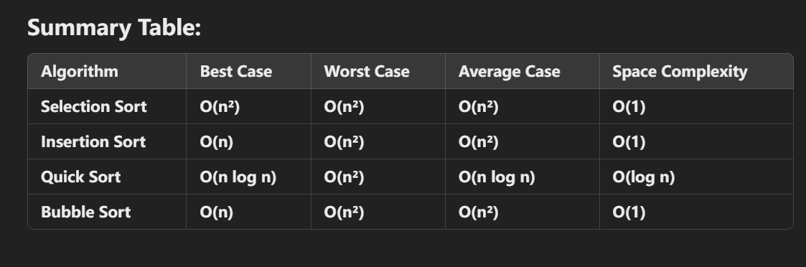



Bubble Sort (Optimized with Early Exit)

Best Case: O(n)  
Description: If the array is already sorted, the early exit condition stops the algorithm after n - 1 comparisons.

Worst Case: O(n²)  
Description: For a reverse sorted array, each pass compares all remaining elements, leading to n²/2 comparisons.

Average Case: O(n²)  
Description: Multiple passes through the array result in quadratic comparisons.

Selection Sort

Best Case: O(n²)  
Description: Always makes n²/2 comparisons, since it scans the unsorted part of the array to find the minimum element.

Worst Case: O(n²)  
Description: Still performs the same number of comparisons, even in reverse order.

Average Case: O(n²)  
Description: Comparisons depend only on the size of the array, not its initial ordering.

Insertion Sort

Best Case: O(n)  
Description: If the array is already sorted, it performs only n - 1 comparisons, as no shifting is required.

Worst Case: O(n²)  
Description: If the array is reverse sorted, each element must be compared and shifted through the entire sorted portion, resulting in n²/2 comparisons.

Average Case: O(n²)  
Description: Requires shifting elements approximately half the size of the current position for random inputs.

Merge Sort

Best Case: O(n log n)  
Description: Always divides the array into equal halves, resulting in log n levels and n comparisons per level.

Worst Case: O(n log n)  
Description: Since merge sort always splits and merges the array, its performance is consistent across input types.

Average Case: O(n log n)  
Description: Maintains consistent performance due to its divide-and-conquer approach.

Quick Sort

Best Case: O(n log n)  
Description: If the pivot divides the array into two equal halves at every step, comparisons are minimized, with log n levels and n comparisons per level.

Worst Case: O(n²)  
Description: If the pivot repeatedly selects the largest or smallest element, partitions become highly unbalanced, leading to n comparisons at each level.

Average Case: O(n log n)